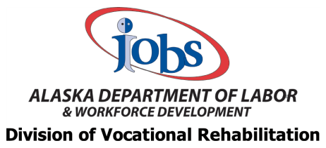

- How would you rate employment opportunities available to students with disabilities in your community?

Great
Acceptable Poor
None
Not Sure Comments

- What skills do your students need in order to be successful in getting and keeping these jobs?

- What is your estimated percentage of students with disabilities having to leave their community to pursue employment, postsecondary education, or training?
100%
75%
50%
25%
0%
Not Sure
Comments

- Please let us know the degree to which your postsecondary transition program focuses on the following Pre-Employment Transition Services:

Always Sometimes Not Yet Implemented

⃝ ⃝ ⃝

⃝ ⃝ ⃝

⃝ ⃝ ⃝

⃝ ⃝ ⃝

⃝ ⃝ ⃝

⃝ ⃝ ⃝

⃝ ⃝ ⃝
Vocational Evaluation
Job Exploration Counseling
Job-Seeking Skills Instruction

Employment Etiquette Instruction
School-Based Work Experience
Community-Based Work Experience
Career-Specific Vocational Training

- Does your district conduct any of the following?

After-School Work Readiness Programs Summer Work Readiness Programs Transition Camps
None

Comments

- What barriers affect students' ability to achieve their postsecondary goals?

Transportation Obstacles Lack of Family Support
Lack of Existing Programs to Meet Specific Disability Needs Lack of Community Resources
Difficulty Accessing or Navigating Statewide Systems Unstable Living Situation
Other Barriers (please specify)

- DVR utilizes the annual Alaska Statewide Special Education Conference (ASSEC) to provide teachers with information and resources. What topics would be a benefit to teachers doing transition activities?
Information around appropriate referral and eligibility for DVR services

Information and resources for accessing state and federal postsecondary transition services (I/DD, Behavioral Health, Social Security)

More information on coordinating pre-employment transition services with DVR

Basic training for teachers on supporting work experiences (job development and job supports) Other (please specify)

- Who is the appropriate school point of contact for coordinating DVR services in your school district? (Optional)

Name

School/District

Email Address

Phone Number

