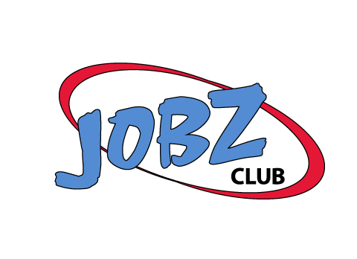Student Exit Survey

Name:

Your feedback can help make JOBZ Club better. Please take a few minutes to complete this survey. Please mark the extent to which you agree or disagree with the following:

- Participating in JOBZ Club helped me understand the importance of soft skills on a job?
Agree | Somewhat Agree | Somewhat Disagree | Disagree

- What I learned about Communication will help me at a job?

- What I learned about Enthusiasm and Attitude will help me at a job?

- What I learned about Teamwork will help me at a job?

- What I learned about Professionalism will help me at a job?

- The activities were helpful for learning the concepts of soft skills?

- I will be a better employee from the skills I learned from JOBZ Club?

Comments or suggestions to make JOBZ Club better:

