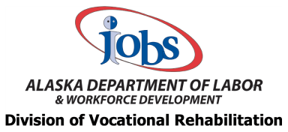

SVRC Vocational Rehabilitation Evaluation Questionnaire

Please mark the box which best describes your opinion on each question based upon your overall experience with the Division of Vocational Rehabilitation (DVR) versus that based on a single incident:

- DVR Staff were polite and helpful on an on-going basis throughout the time I had an open case,
⃝ Agree
⃝ Disagree

Comments:

- I knew from the start that the goal of DVR was to help me find employment or stay employed.
⃝ Agree
⃝ Disagree

Comments:

- DVR staff replied promptly to my questions, requests, and informed me of changes.
⃝ Agree
⃝ Disagree

Comments:

- Alaska DVR helped me understand my abilities so that I could choose a job consistent with my strengths, resources, priorities, concerns, capabilities, interests, and informed choice.
⃝ Agree
⃝ Disagree

Comments:

- I was pleased with my involvement in the decision making process that led to my plan for employment.
⃝ Agree
⃝ Disagree

Comments:

- I was aware of my right to disagree and was informed about the process to appeal DVR decisions and about the Client Assistance Program (CAP).
⃝ Agree
⃝ Disagree

Comments:

- Alaska DVR staff helped me understand the services available to me by DVR and other agencies.
⃝ Agree
⃝ Disagree

Comments:

- Overall, I am satisfied with the services I received.
⃝ Agree
⃝ Disagree

Comments:

- I would recommend Alaska DVR to others.
⃝ Agree
⃝ Disagree

Comments:

- Do you have any suggestions for ways to improve the program? Please be specific.

